Introduction To Software Development – Extra Questions
CSC 300 Fall 2026
Total Points -

Short answer questions.

- List three characteristics of good naming conditions, as defined by Robert Martin.

- Self-Explanatory
- Meaningful distinctions
- Pronounceable

- Define what an immutable class is in Java

In Java, an immutable class is a class whose state cannot be changed once an object of that class is created. This means that the values of its instance variables cannot be modified after initialization.

- Describe the Defect Types discovered during Static Analysis (Look at the pdf version of the table and find the correct box)
- Design defects
- Insufficient functional requirements
- Inconsistent design and architecture.specifications
- Memory and buffer overflows
- Code complexity
- Code, syntax, and standardized labeling errors

- List/describe the characteristics of a pure function (6)
- They do not modify any state or have any side effects.
- They only depend on their input parameters.
- They are predictable and have a deterministic behavior and are easier to test, debug, and maintain.

- List/describe the characteristics of an impure function (6)
- They can modify the state of the application or have side effects.
- They depend on other parts of the code.
- They are unpredictable and can have a non-deterministic behavior and are harder to test and maintain.

- What is a functional interface in Java? (5)
A functional interface in Java s an interface with exactly one abstract method (SAM - Single Abstract Method), serving as a target for lambda expressions and method references, allowing behavior to be passed as data

- Describe lazy evaluation. (5)
- Lazy evaluation, or call-by-need, is an evaluation strategy which delays the evaluation of an expression until its value is needed (non-strict evaluation) and which also avoids repeated evaluations (by the use of sharing)
  - The &&, || and ?: operators are the conventional way to do lazy evaluation in that they only evaluate until the result is determined – (a||b) || (a && c)

Problems:
- Cyclomatic Complexity (6 points)
Calculate the cyclomatic complexity for the following figure, assuming a single exit node. Show your formula and calculation to ensure partial credit.
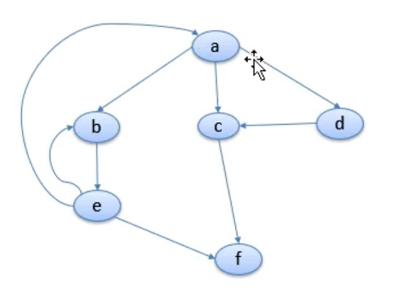

Answer:
Cyclomatic Complexity = E – N + 2*P = 9 -6 +2 = 5

